Data Structures and Algorithms Lab
Assignment 6
Experiment 6 (Binary Search Tree and Heap)
- To demonstrate the creation of a binary search tree and implement its operation.
- To create a binary heap data structure and implement its operations, and its applications.

Instruction: Make a pdf file of the program code in C and its output.
Name: Aditi Srivastava
SAP ID:590026127
Batch: 39
Link of your GitHub Account:
Course: B.Tech. CSE (Sem II)
Subject: DSA Lab
Date: 14 April 2026
Note: Do all the implementations in C programming.
- Write a C program to implement a Binary Search Tree (BST) using a linked list representation. Your program should support the following operations:
- Insertion: Insert a node into the BST while maintaining BST properties. Duplicate values should not be allowed.
- Deletion: Delete a node from the BST based on a given key.
- Handle all three cases: (a) Node is a leaf node, (b) Node has one child and (c) Node has two children
- Searching: Search for a given value in the BST (Display whether the element is found or not).
- Traversal: In order Traversal (Left → Root → Right).
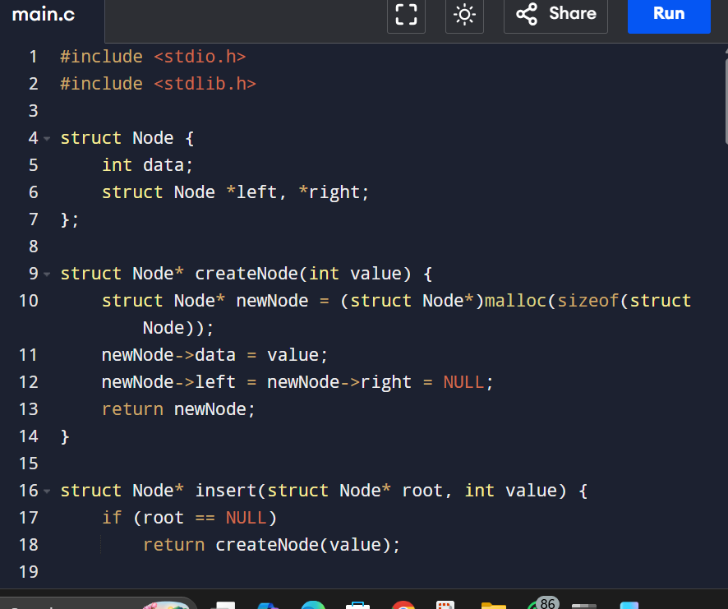
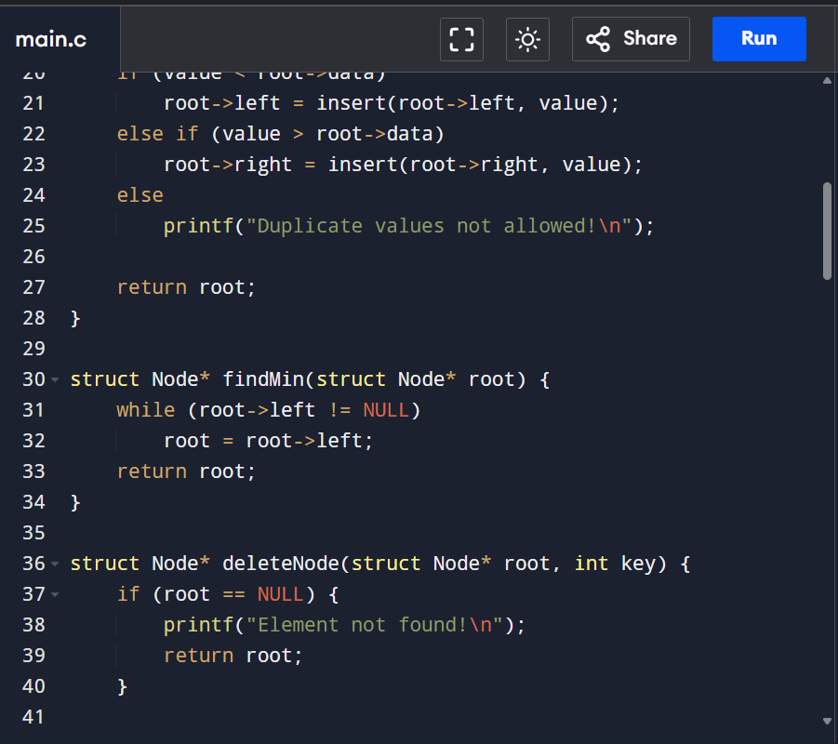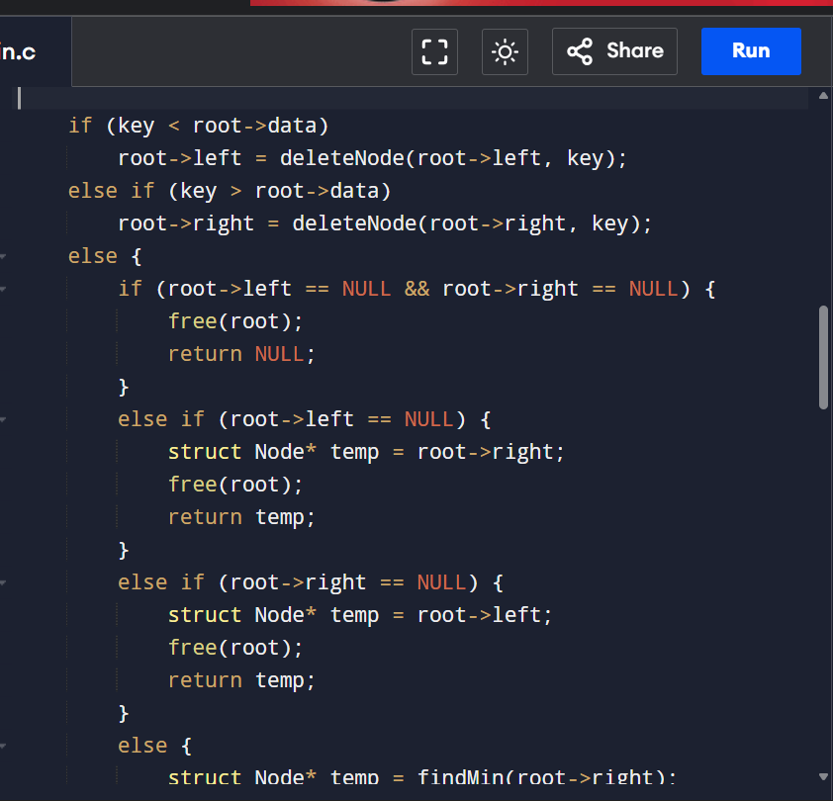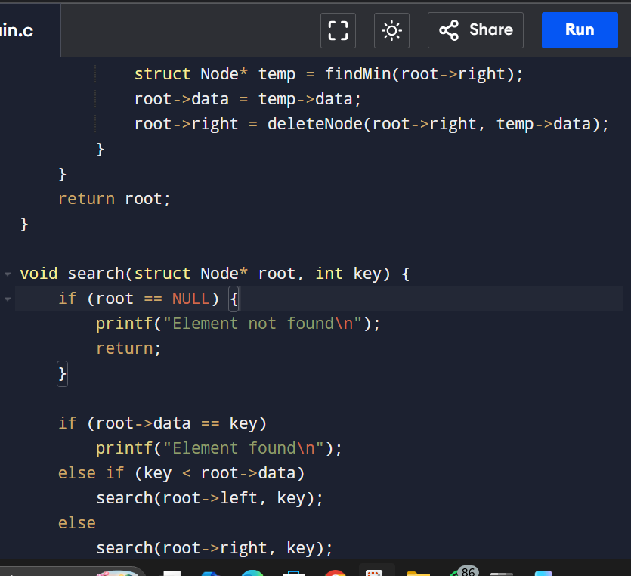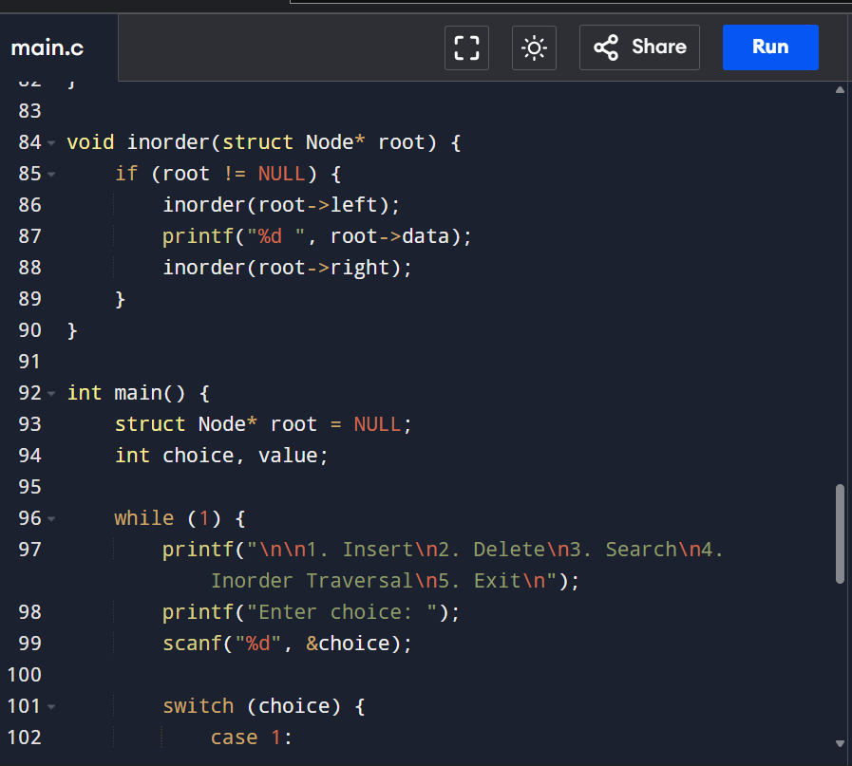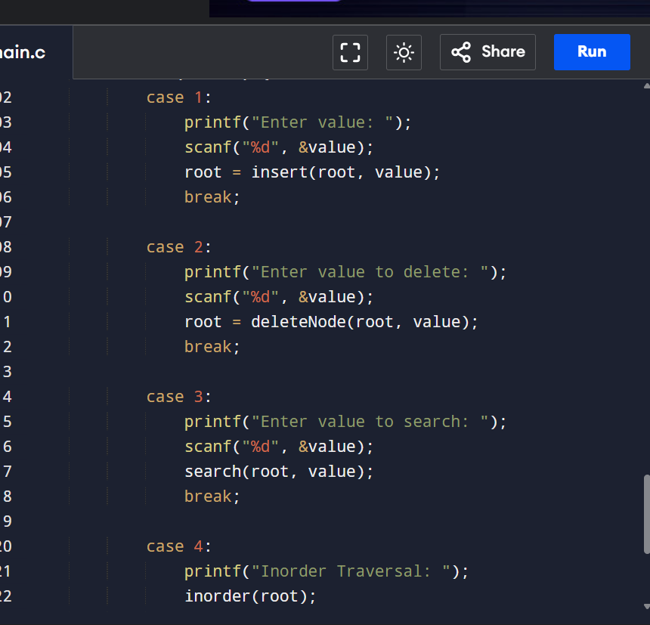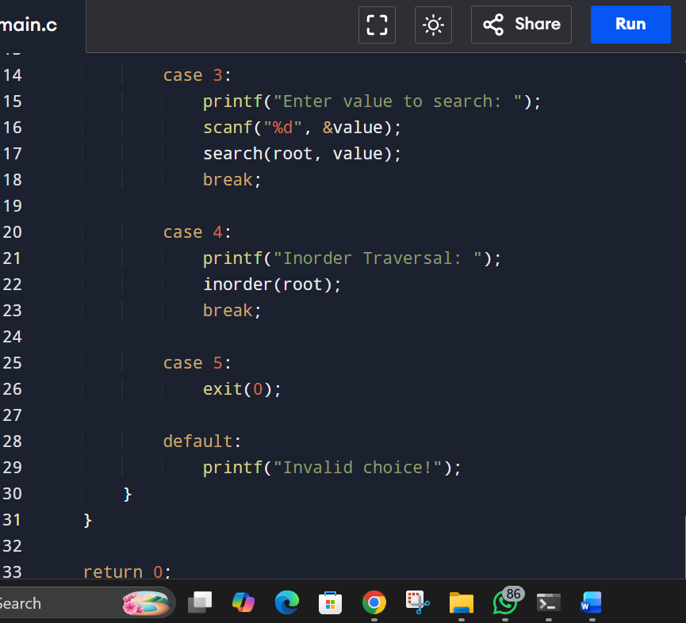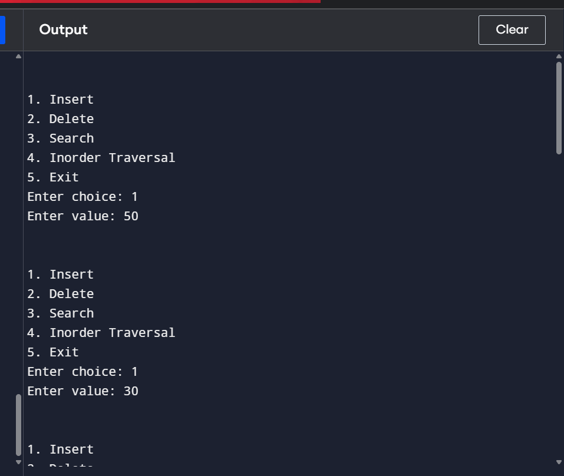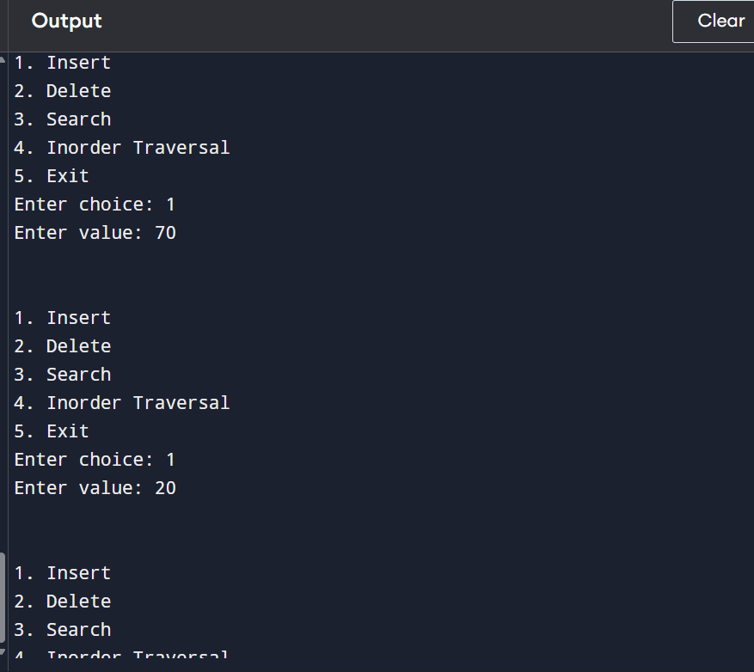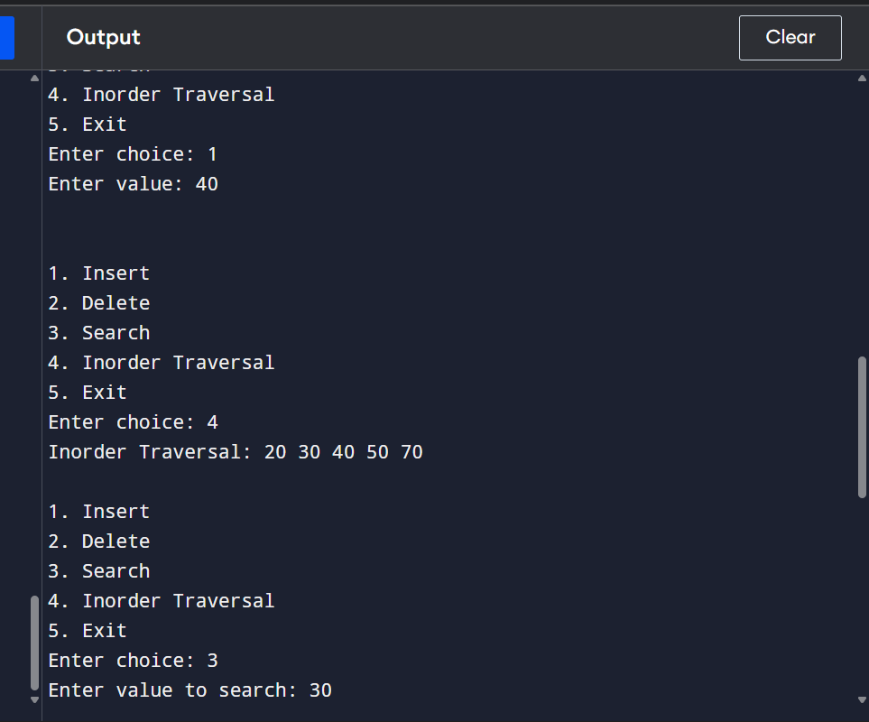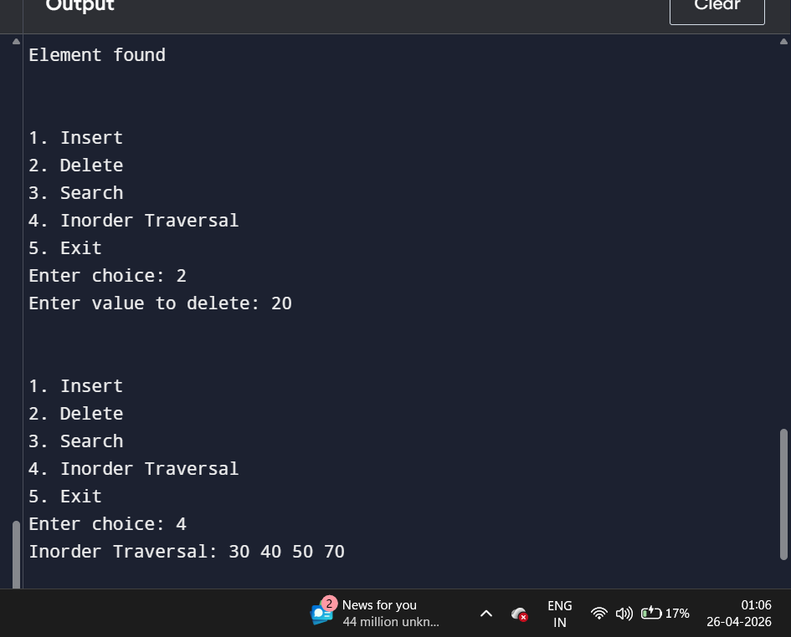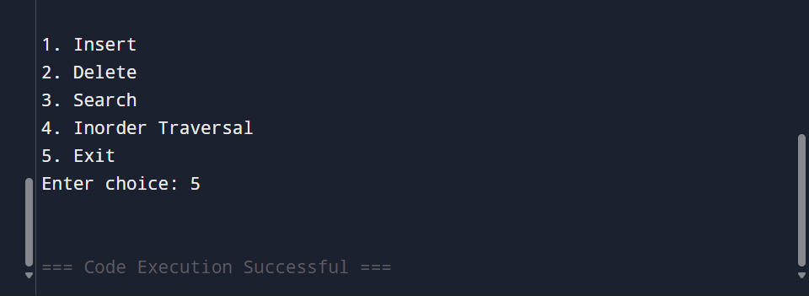
- Write a C program to implement a Binary Heap (Min Heap or Max Heap). The program should support the following operations:
- Heap Creation: Initialize an empty heap using an array.
- Insertion (Heapify-Up): Insert a new element into the heap. Maintain the heap property using heapify-up operation.
- Deletion (Heapify-Down): Delete the root element (minimum in Min Heap / maximum in Max Heap). Maintain heap property using heapify-down operation.
- Display Heap: Print the elements of the heap.
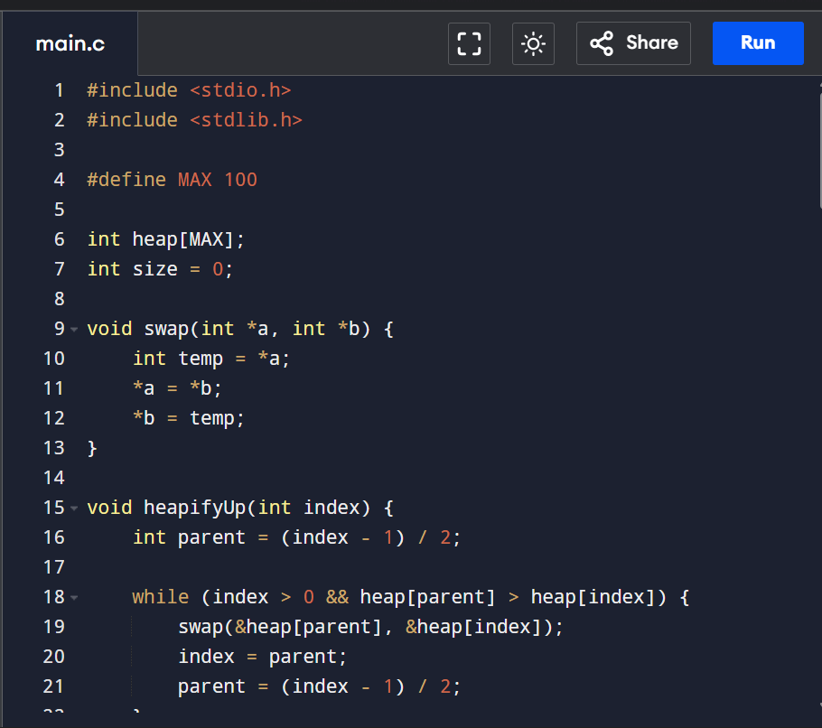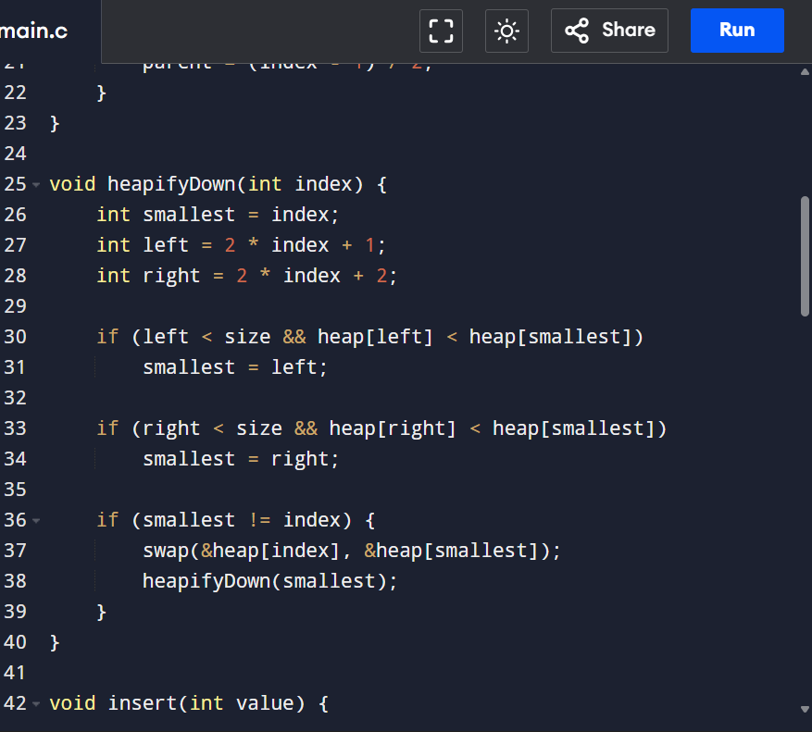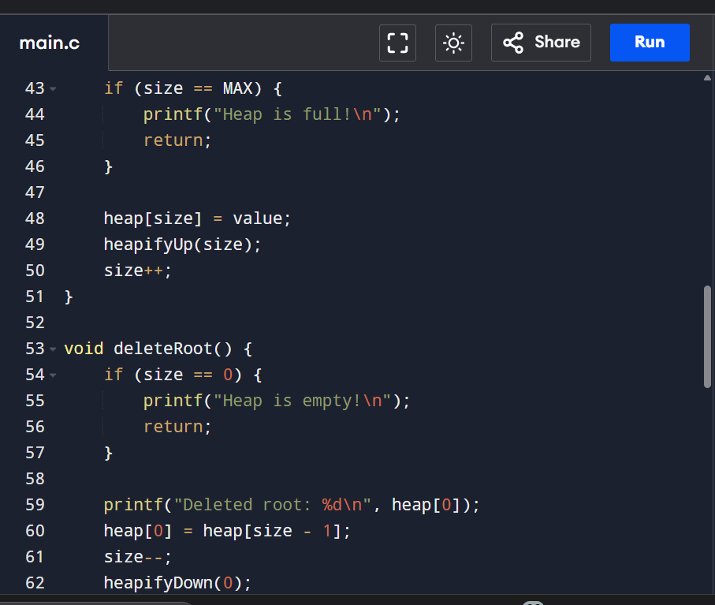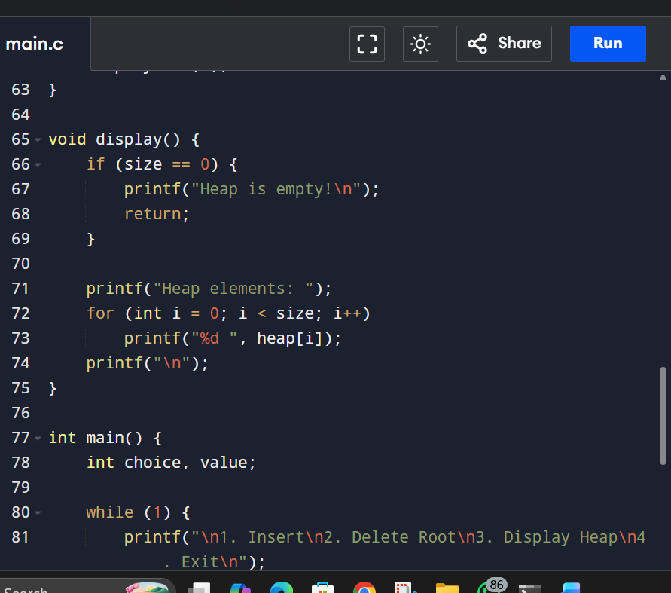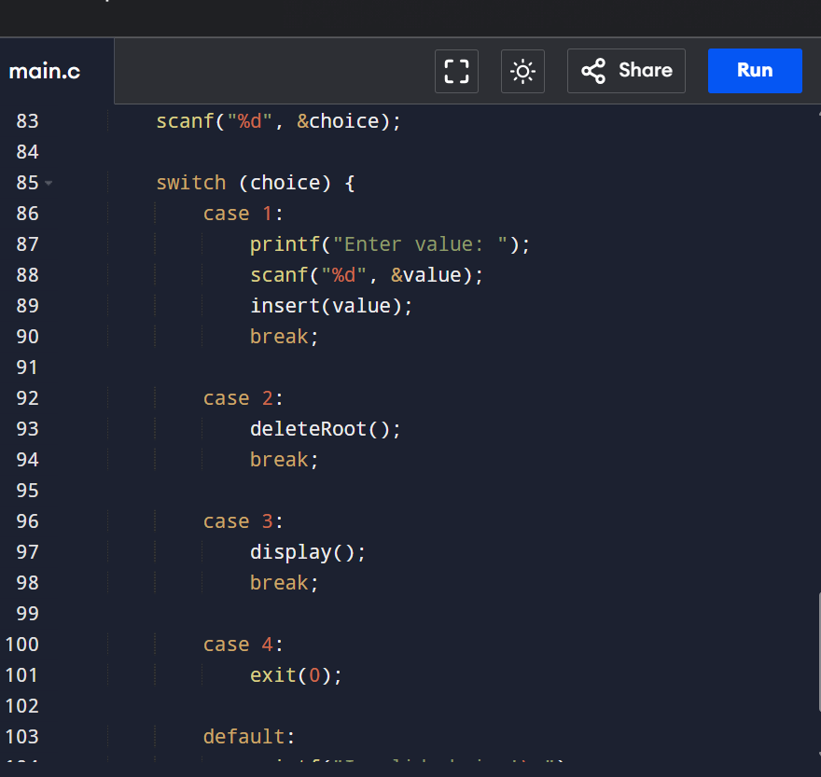
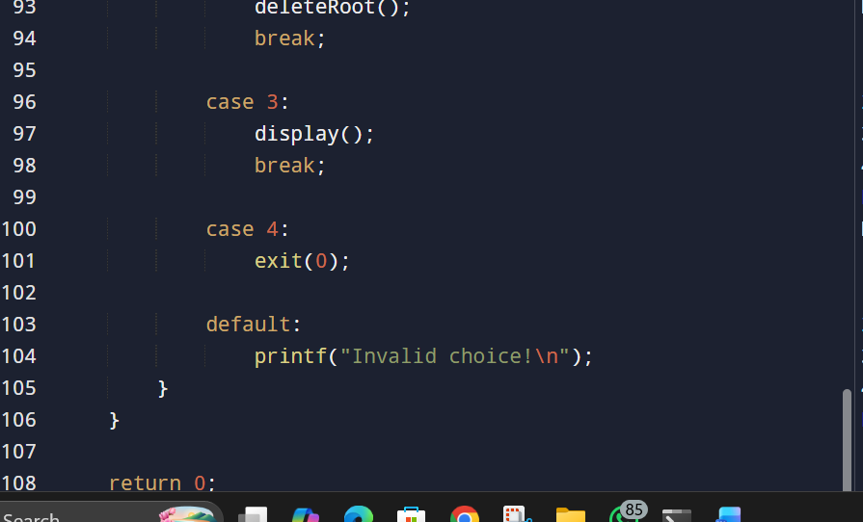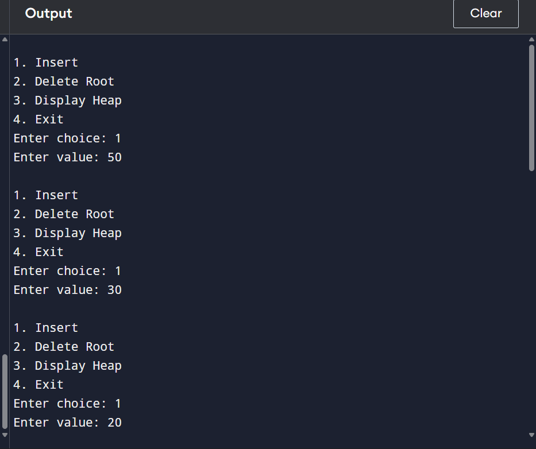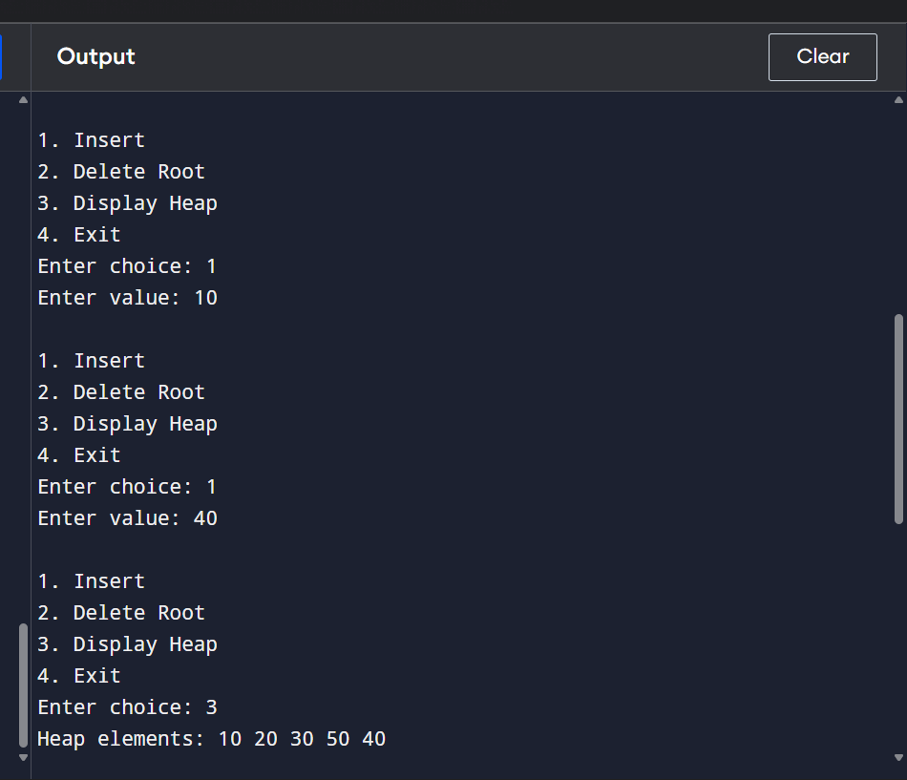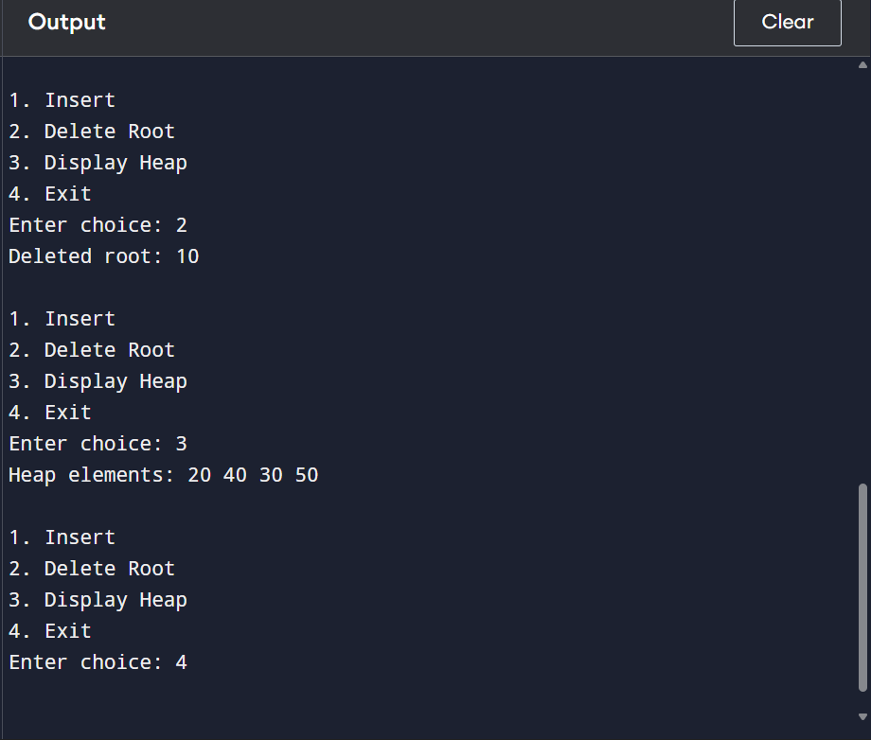
- Write a C program to implement a Priority Queue using a Binary Heap (Min Heap or Max Heap). The program should support the following operations:
- Insert (Enqueue with Priority): Insert an element along with its priority into the queue. Maintain heap property using heapify-up.
- Delete (Dequeue Highest Priority Element): Remove the element with the highest priority: (Min Heap → smallest element) and (Max Heap → largest element). Maintain heap property using heapify-down.
- Peek: Display the element with the highest priority without removing it.
- Display: Print all elements of the priority queue.
